WKUF On Demand And Song Request

Devin Holland

Lucas Brandt

Jacob Miller

http://webtech.kettering.edu/~holl4332/webproject/demo/form.html

Description:

Our project was broken into two parts: on demand radio and song request. The on demand radio feature allows DJs to upload their show to the website so anyone can listen to the show at any time. Another page handles all the uploaded shows. You can sort the shows by the DJ's name and when the show aired. In addition, there is an imbedded player in the page so you can listen to the desired shows. This allows anyone to listen to a past show whenever they want.

Currently there is no convenient way to request a song for a show. DJ's usually take request from Facebook or other social media platforms. This is not an ideal way because it requires someone to know the phone number for the station or know the DJ on Facebook. Therefore, being able to request songs online would be a big improvement for both the DJs and the people who wish to request a song to be played on air for them. The song request feature of the website allows listeners to fill out a form for a song they wish to be played. DJ's can then look at another page which displays the requested songs.

All these features will eventually be placed on WKUF's website for easy access by DJs and Listeners.

Need

Currently, WKUF does not have an effective way for a user to request a song. They would either have to know the phone number for the station or they would need to know the DJ on Facebook and contact them through that means. This is not an ideal way and it would be a big improvement for both the DJs and the people who wish to request a song to be played on air for them.

Approach

We started with the on-demand and song request features. We split up the team such that two people worked on the on-demand feature as it required more work, and one member of the team worked on the song request feature.

Benefit

As stated previously, this project will greatly benefit the DJs of the radio station as well as Kettering students and members of the Flint community that listen to the station. This will consolidate the song request process into one location for the DJs to check and listeners to visit. Many other radio stations have a song request section. Some DJs of other radio stations have their broadcasts saved as podcasts for users to listen to from the website. This will help Kettering’s WKUF to continue to thrive and grow in listenership.

Competition

The competition to this project is other radio stations throughout the Flint area. These radio stations are commercial so it is not expected that our project will increase listenership to surpass any of these stations, but WKUF has a loyal listenership for its shows and this will help to make those listeners happy and hopefully attract more.

Marketing

We communicated with the current leads of WKUF and discussed the features. They were very interested in these additions.

Architecture

The song upload pages inserts the show and show data into a MySQL database. The on demand page reads from that table to get the uploaded shows. The song request pages writes the requested songs to a different table in the MySql Database. Finally the request list page reads from the song request table and displays the requested songs.

Technology

The website is written in HTMl and PHP. A MySQL database is used to store the uploaded songs and the song requests. A JavaScript audio player called jPlayer is used for streaming the shows on the webpage.

Requirements

The requirements for this project were:

* The website must allow DJ's to upload their shows
* The website must allow anyone to listen to the uploaded shows
* The website must allow listeners to request songs
* The website must display request songs

All of our requirements were met.

User Manual / Examples

Podcast Upload

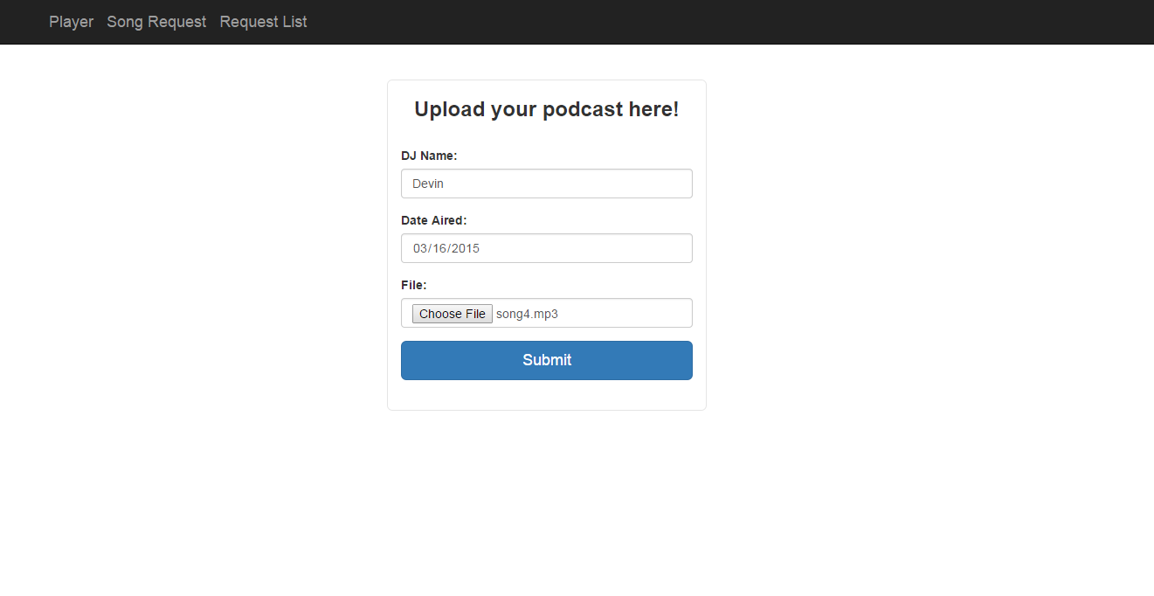

To upload a podcast, you enter the DJ's name, the date it aired, and the mp3 file. You then click submit.



This will redirect you to a page confirming that the file has been uploaded. There is also a button to navigate back to the upload page.

Player

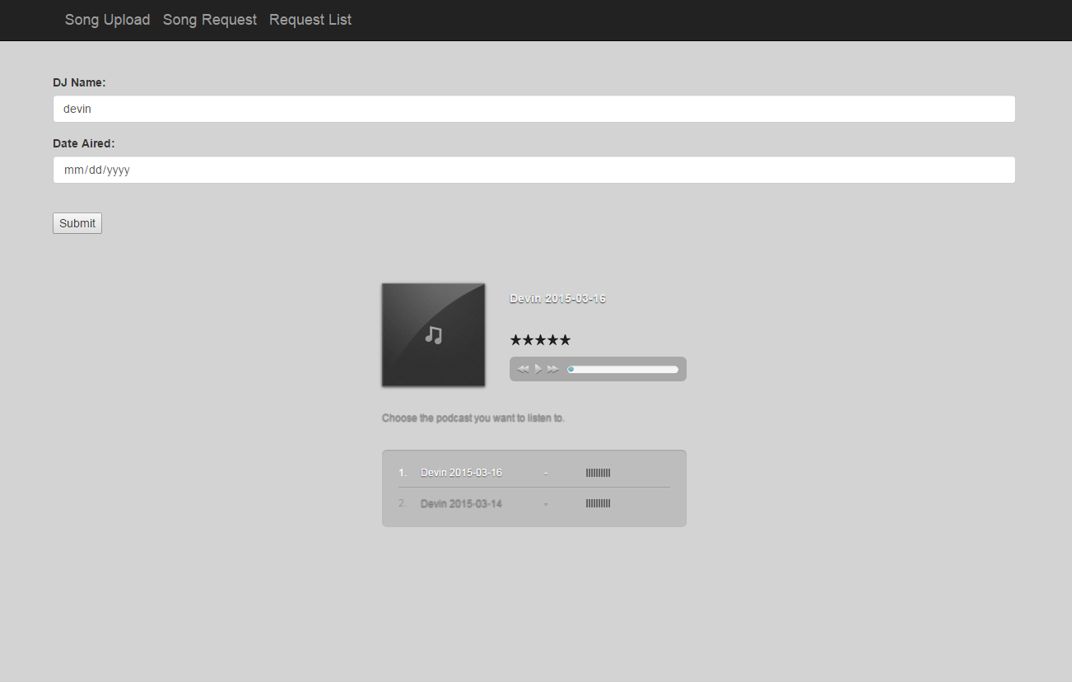

To search for a show, enter the name of the DJ and/or the date the show aired and click the submit button. This will show all the shows that match the filter. To listen to a show simply click on it.

Song Request

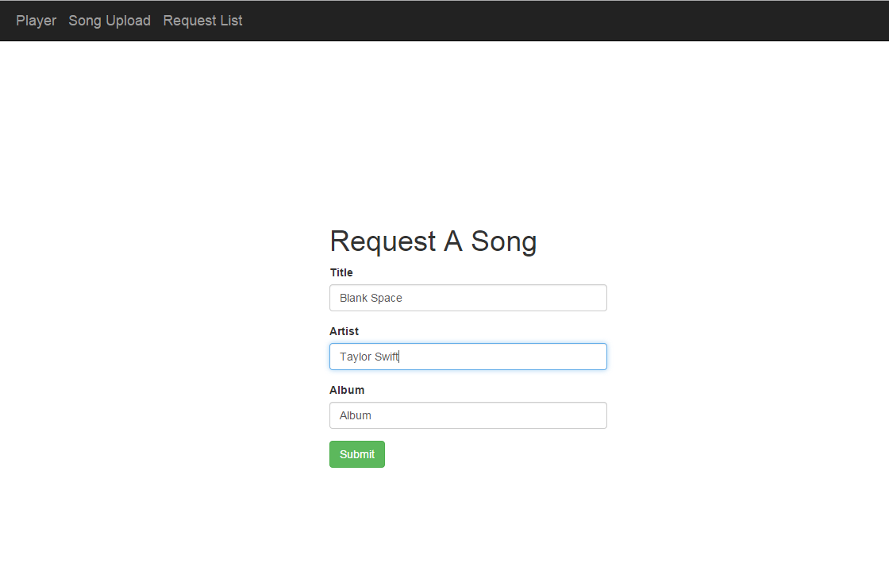

To request a song, enter the title, artist, and album into the form and click submit.



This will redirect you to a page confirming that the song has been requested. There is also a button to navigate back to the request page.

Request List

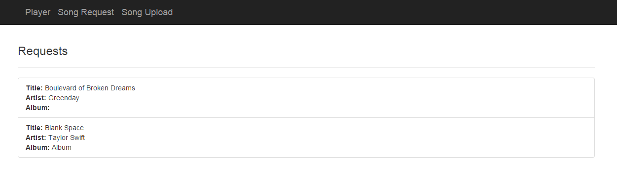

This page simply displays the requested songs.